Non-paper: COVAX Facility governance structure

The purpose of this paper is to support the development of robust, effective and accountable governance of the COVAX Facility.

- The success of the COVAX Facility will rely not only on the strength of commercial commitments from self-financing participants, but also on a lasting political licence to operate. Participants will have both self-interests (represented through their binding commitments with the Gavi Alliance, as the legal entity) and collective-interests, which they will want to continue to pursue through an appropriate and effective governance mechanism. As an existing legal entity Gavi has been used to administer the Facility in order to save time and leverage the track record of Gavi and its Alliance. Hosting of the Facility should not impede Gavi’s existing vital programmes.

- The Gavi Alliance will establish the Office of the COVAX Facility to execute the mandate derived from its binding commitments with participating economies. The Office of the COVAX Facility will need to implement these mandated technical processes with agility in an environment of urgency and uncertainty. Participating economies will need oversight of these processes to provide assurance that the COVAX Facility is executing its mandate appropriately. Participating economies will also require a mechanism through which they can guide the COVAX Facility’s strategic direction and take decisions on emerging strategic issues not covered or fully defined in the Terms and Conditions or Commitment Agreements (for example the COVAX Exchange).

- This non-paper explores the locus of roles and responsibilities in a possible COVAX Facility governance structure in accordance with a set of proposed principles, which aim to balance fast-paced technical decision-making and ensuring participating economies retain high-level oversight of the COVAX Facility’s operations and strategic direction.

Principles

- The COVAX Facility governance structure should enable and provide:

- the highest standards of ethics;

- transparency through regular information sharing;

- accountability to all participating economies through regular progress and outcome reporting;

- high-level direction-setting to technical bodies;

- non-politicisation through charging expert technical bodies to make agile, efficient and responsive decisions; and

- clearly defined roles for governance bodies of the COVAX Facility and their interaction with the ACT Accelerator Facilitation Council, and the Gavi/CEPI/WHO Boards; and clear delineation of the decision-making mandate of the Office of the COVAX Facility.

Proposed structure

- Please refer to Annex 1 for a diagram overview of the discussion below on the COVAX Facility governance process, and a table overview of the breakdown of roles and responsibilities in Annex 2. The proposal builds on governance structures established in the Terms and Conditions and is informed by feedback received from members of the Friends of the COVAX Facility.

Delegation of authority

- The Gavi Board is responsible for strategic direction and policy-making, oversees the operations of the Gavi Alliance and monitors programme implementation and performance effectiveness. The Gavi Board has approved the Gavi Alliance as the legal entity to administer the COVAX Facility. Participating economies enter into legal agreements with the Gavi Alliance. Commitment Agreements between participating economies and the Gavi Alliance (as the legal entity) collectively establish the mandate of the COVAX Facility.

- The Gavi Alliance therefore has the authority to administer the COVAX Facility in line with the legal obligations set out in the Commitment Agreements and accompanying Terms and Conditions. The Gavi Alliance establishes, and delegates operational decision-making relating to the COVAX Facility, to the Office of the COVAX Facility, being established within the Gavi Secretariat.

- The Gavi Board could formally delegate leadership for major operational and strategic decisions relating to the self-financing cohort within the COVAX Facility to the Shareholders Council (and Shareholders Executive Committee, as appropriate) (see paragraphs 11 and 12 below).

- An independent dispute resolution mechanism is provided to resolve disputes arising from Commitment Agreements between participants and the Gavi Alliance. Proposals for this should be developed by Gavi and CEPI, that accord with the legal arrangements within commitment agreements and the operations of Gavi as a legal entity.

Implementation

- The Office of the COVAX Facility is responsible for making operational decisions already mandated by the Commitment Agreements. These decisions are informed by technical advisory bodies, which in turn draw on established expertise from the WHO, CEPI, Gavi, UNICEF and others. Some of these bodies are already established as a part of the Gavi Alliance (namely, the Market Sensitive Decision Committee and the Audit and Finance Committee) while other technical advisory bodies will be convened by the Office of the COVAX Facility independently (namely the Independent Product Group and the Product Reference Group) or in conjunction with the WHO (the Joint Allocation Taskforce). The Office of the COVAX Facility operates within the legal and institutional framework of the Gavi Alliance (including utilising existing systems/frameworks for HR, work health and safety, and fraud).

- The Shareholders Council, comprising a single representative of each self-financing economy, meets quarterly [or at least twice yearly] to provide strategic oversight and accountability of the Office of the COVAX Facility’s implementation of Commitment Agreements with self-financing economies, and to lead policy and strategic decisions related to the COVAX Facility. In the spirit of collaboration, the Council could also consider inviting a representative of the AMC Stakeholders Group, World Bank, UNICEF, WHO, CSOs and the Bill and Melinda Gates Foundation as participants or observers, subject to agreement by Shareholders Council members.

- The Shareholders Council elects an Executive Committee, which meets intercessionally (as often as required) to provide oversight and strategic guidance, on behalf of the Shareholders, of operational decisions made by the Office of the COVAX Facility. The Shareholders Executive Committee would provide recommendations to the Shareholders Council on major operational or strategic decisions for endorsement/approval as appropriate.

- In parallel, the AMC Stakeholders Group and the Gavi Board provide strategic and operational oversight of the work of the Office of the COVAX Facility that relates to AMC funding, performance and allocation, alongside Gavi’s existing operations.

- As part of their accountability function, the Shareholders Council and the AMC Stakeholders Group receive independent audit reports on the work of the Office of the COVAX Facility. This would be supported by the Gavi Alliance’s Audit and Finance Committee, and may be assisted by the Evaluation Advisory Committee upon request. Deloitte is the current independent audit provider. To facilitate full transparency, the Chair/s of the Shareholders Council and Executive Committee could observe the Audit and Finance Committee for discussions related to the COVAX Facility. The Shareholders Council may consider inviting the Audit and Finance Committee Chair to attend the Shareholders Council and Executive Committee.

- The Shareholders Council and AMC Stakeholders Group will report on their assessment of the performance of the COVAX Facility to the Gavi Board (as the legal implanting entity). The Gavi Board and the Shareholders Council will consider opportunities to improve the operations and governance of the COVAX Facility in order to ensure participating economies are able to exercise appropriate governance oversight and the operations of the COVAX Facility do not interfere with Gavi’s core mandate.

- Where new and/or strategic decisions are required in respect of self-financing economies, the Office of the COVAX Facility receives guidance from the Shareholders Council (including as facilitated by the Executive Committee). Issues could include (but are not limited to) the function of COVAX Exchange, allocation of doses above 20%, and longer term operations of the Facility. The Chair/s of the Shareholders Council and the Executive Committee will be invited to attend the Gavi Board and, in the spirit of effective cooperation, the Chair of the Gavi Board will be invited to attend the Shareholders Council and Executive Committee.

- The Gavi Board also delegates some decision-making powers to the Market Sensitive Decisions Committee to review and approve the business terms of proposed agreements with manufacturers. Three additional members are elected by the Shareholders Council to provide for input by representatives of self-financing economies into the review of COVAX related contracts with manufacturers.

- The nominations and elections process for the Executive Committee and Shareholders Council representatives on the Market Sensitive Decisions Committee should encourage diverse representation of self-financing participants. Accordingly, self-financing participants are encouraged to respect this need when considering standing for election.

Establishment and next steps

- The detail of the form and function of the Shareholders Council and Executive Committee are not mandated in the Terms and Conditions. It will be necessary to reach a consensus amongst participants regarding the role of the Shareholders Council and Executive Committee, including the threshold and process for strategic guidance, advice, decision-making and operational oversight. To this end, it is important that self-financing participants work with the Gavi Secretariat to draft Terms of Reference and Operating Procedures for the Shareholders Council and Executive Committee based on views of participating economies. The Gavi Board (as the legal entity) would note the draft Terms of Reference and Operating Procedures, subject to adoption by the Shareholders Council.

- The first meeting of the Shareholders Council should then agree and adopt the Terms of Reference and Operating Procedures and elect chair/s and representatives to the Executive Committee and the Market Sensitive Decision Making Committee. It is assumed that Gavi’s existing Operating Procedures and policies will be used by the Council (for example conflict of interest declarations, and gender policy) in the interim until Operating Procedures are agreed.

Annex 1: COVAX Facility governance process
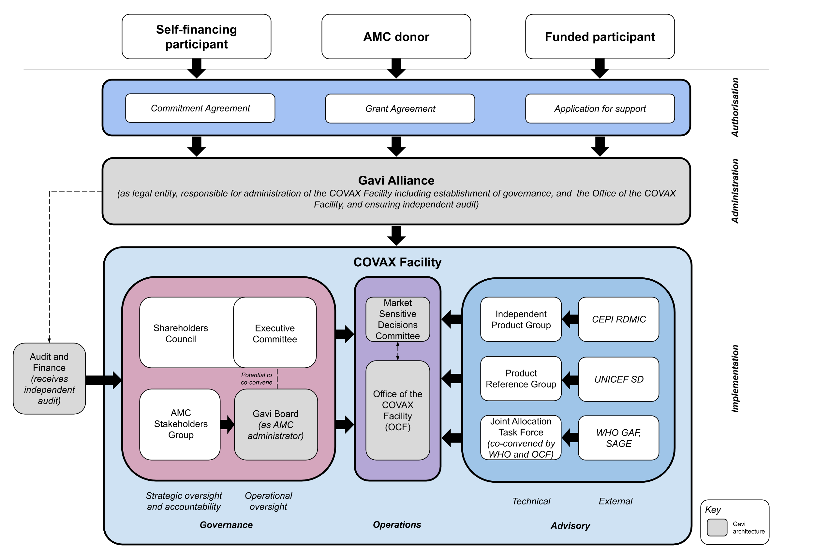

Annex 2: Delegation of roles and responsibilities

Role | Body | Members | Responsibilities
Audit | Audit and Finance Committee (AFC) | - Existing Gavi committee, whose mandate covers all operations of the Gavi Alliance including the COVAX Facility.  - Chair/s of the Shareholders Council and Executive Committee could observe the Audit and Finance Committee for discussions related to the COVAX Facility. | - Ensures availability of necessary funding and monitoring for risk.  - Receives and reviews independent audits of the COVAX Facility, reporting to the Gavi Board, briefing SC and making recommendations as appropriate. Deloitte is the current independent audit provider.
Strategic oversight and accountability | Shareholders Council (SC) | - All self-financing participants. Possibility to include observer members represented in the AMC Stakeholders Group, subject to agreement by the SC. Co-chairs to be elected from the Council (one HIC and one UMIC), but for the first meeting to be co-chaired by the Board Chairs of CEPI and Gavi [or the ACT Accelerator Special Envoys].  - Ability to invite technical experts, relevant bodies or others to present or provide advice to the SC as relevant to discussions.  - All members are treated equally in terms of membership, rights and privileges.  - Membership in the Council lasts for the duration of an economy’s participation in the Facility (i.e. ceases if an economy withdraws).  - Members appointed to the Shareholders Council should be senior representatives, and have the ability to appoint alternates. | - Provides strategic guidance and advice to the OCF on non-technical and management matters related to self-financing economies  - Receives quarterly reports from the OCF on operational progress and financial updates.  - Leads, shapes and takes decisions for the Council members as necessary on major operational and strategic decisions, including unforeseen or unresolved strategic issues, related to the self-finanicng cohort e.g. endorsing a proposal on the COVAX Exchange.  - Makes recommendations/decisions by consensus, or if voted, by majority vote. Options for voting are one vote per economy representative, or votes allocated to economies weighted by percentage share of investment. (Note: Decision-making processes, including voting procedure, within the SC would be subject to adoption by the SC of agreed Operating Procedures.)  - Chair/s may attend the Gavi Board to engage on major operational and strategic decisions relating to the COVAX Facility self-financing and funded cohorts. The Chair of the Gavi Board will be invited to attend the SC.
Strategic oversight and accountability | AMC Stakeholders Group (noting this will be determined as appropriate by the Gavi Board) | - Representatives of donors, funded participants, and independent organisations (including Gavi, WHO). | - Provides strategic guidance and advice to the OCF on non-technical and management matters related to the AMC.  - Receives quarterly reports from the OCF on operational progress and financial updates.
Operational oversight | Shareholders Executive Committee | - Representatives elected from the SC, including one Chair or two Co-Chairs.  - Representation will be finalised once a list of participating economies is available on a suitably representative basis. A hybrid model which recognises various regions, income-level (HIC/UMIC) and size of investment and economies, as well as level of investment into the COVAX Facility, will be used.  - Self-financing participants are encouraged to respect the need for diverse representation when considering standing for election to the Shareholders Executive Committee.  - In the interest of transparency, the Executive Committee would be open to observers from all self-financing economies. | - Receives regular reports from the OCF on technical decisions, operational progress and financial updates.  - Provides a “sounding board”/consultative mechanism for OCF decisions related to self-financing participants between SC meetings.  - Identifies recommendations/ decisions which should be put to the Shareholders Council.  - Conducts more detailed discussions on forthcoming issues for the SC, determines SC agendas, and develops papers for SC consideration where required (e.g. on the COVAX Exchange).  - Chair/s may attend the Gavi Board to engage on major operational and strategic decisions relating to the COVAX Facility self-financing and funded cohorts. The Chair of the Gavi Board will be invited to attend the Executive Committee.
Operational oversight | Gavi Board | - Existing membership, whose mandate covers all operations of the Gavi Alliance including the COVAX Facility. | - Provides strategic direction and policy-making, including in coordination with the Shareholders Executive Committee as appropriate.  - Oversees the operations of the Gavi Alliance.  - Approves the Gavi Alliance as the legal entity to administer the COVAX Facility and has a responsibility to ensure that the Gavi Alliance acts within it’s mandate in this role. The Gavi Alliance, as the legal entity, is formally responsible for decisions and effective implementation of the COVAX Facility.  - Receives regular reports for information from the Shareholders Council on operational progress and performance.  - Recieves financial updates (including from the AFC and MSDC) on all Gavi Alliance operations.  - Provides strategic oversight of the COVAX AMC and effective implementation including country engagement.
Operational decisions | Office of the COVAX Facility (OCF) (established and operating within the Gavi Alliance as the legal entity) | - Staffed by experts employed by the Gavi Alliance and funded by Facility operating costs. | - Enters into Commitment Agreements.  - Enters into and monitor implementation of agreements with manufacturers, and agreements with pooled procurement mechanisms.  - Manages investment portfolio based on technical advice.  - Makes allocation decisions in line with Terms and Conditions.  - Provides financial reports.
 | Market Sensitive Decisions Committee | - Existing Gavi committee, whose mandate covers all operations of the Gavi Alliance including the COVAX Facility. Three additional members will be appointed to represent the SC.  - Self-financing participants are encouraged to respect the need for diverse representation when considering standing for election to Market Sensitive Decisions Committee. | - Reviews and approve business terms of proposed agreements with manufacturers.  - SC representatives to the MSDC provide input into review of contracts with manufacturers.
Advisory | Independent Product Group | - Independent experts, with advice from WHO and CEPI. | - Provides technical assessment of vaccine candidates, including: clinical trials analysis; regulatory approval pathways; vaccine manufacture considerations; vaccines distribution and administration considerations to the OCF.  - Informs vaccine portfolio management and investment, and manage development and supply risks.
Advisory | Product Reference Group | - Independent experts, supported by UNICEF SD. | - Provides advice on vaccine candidates’ commercial attributes, including price and timeline of supply to the OCF.
Advisory | Joint Allocation Task Force | - Independent experts, co-convened with the WHO, with advice from SAGE. | - Prepares allocation proposals on the basis of technical, data-driven analysis, the WHO Allocation Framework, and in line with Terms and Conditions to the OCF.

